**Web Portal 1.0**

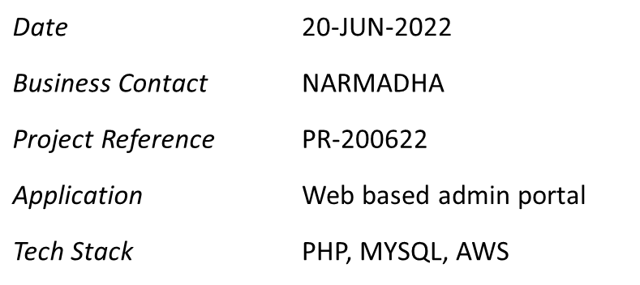

Test summary report

**VERSION 1.0**

DOCUMENT HISTORY

| **DOCUMENT APPROVAL HISTORY** | |
| --- | --- |
| Prepared By | Narmadha H |
| Reviewed By | XYZ |
| Approved By | *AABBCC* |

| **DOCUMENT REVISION HISTORY** | | | |
| --- | --- | --- | --- |
| Date | Document Version | Revision Description | Author |
| 20/06/2022 | 1.0 | Initial Version | Narmadha H |
| 21/06/2022 | 1.1 | Updated Test Coverage and Defect Report | Narmadha H |
|  |  |  |  |
|  |  |  |  |
|  |  |  |  |
|  |  |  |  |
|  |  |  |  |
|  |  |  |  |
|  |  |  |  |
|  |  |  |  |

TABLE OF CONTENTS

1. INTRODUCTION 1

2. test summary report template 1

APPENDIX A. test measure examples A-1

# INTRODUCTION

The Test Summary Report summarizes the results of the testing activities, provides an evaluation based on the results, advises on the product’s release readiness, and documents any known product shortcomings. This report allows the Test Manager to summarize the testing and to identify limitations of the software and the failure likelihood. There should be a Test Summary Report that corresponds to every test plan. In essence, the Test Summary Report is an extension of the test plan and serves to “close the loop” on the plan. This document can be used during change control to summarize testing efforts in preparation for production deployment.

This document is organized into two components: Test Summary Report template and Appendix (i.e., Test Measures (e.g., charts, graphs]).

# test summary report template

Test Summary Report for Web Portal 1.0 Implementation

|  |  |  |
| --- | --- | --- |
| **GENERAL INFORMATION** | | |
| **Test Level: *[Select the Test Summary Report Test Level.]* Summary Date: *22-Jun-2022***  Unit  Integration  Functional  Performance  Acceptance  ☐ Other ***<< Specify Test Level >>*** | | |
| **Application:**  ***Web based portal for user administration*** | | **Build, Version/Revision Number:**  Ver 10.1.1 |
| **SUMMARY** | | |
| **TEST PERFORMED** | * *Unit Testing has been performed by the developers as part of the coding & review* * *Functional testing has been carried out to test the core functionalities such as*    + *New User Registration*   + *User & Role management*   + *Customer management*   + *eKYC Validation Screening / Settings*   + *Credit and Refunds Processing*   + *Claims Backoffice processing*   + *Setting up Notifications*   + *Reports management*   + *Dashboard View management*   + *Export Member & Claims data* * *Reference Test Case - Web_AdminPortal_Testcase_V1.0.xls* * *Katalon – Automation tool has also been used for testing* * *Two iterations of testing has been carried across test cases across sprints* | |
| **DEVIATION (VARIANCES) & RESIDUAL RISK** | * *Additional test cases are needed to increase the test coverage due to problems encountered while executing tests for system functionality to cover “Session handling” or “Account Lockout”* | |
| **TEST COMPLETION EVALUATION** | * *Extended testing has been covered that covers all the functional pointers as per the above-mentioned scope / features in the portal* * *Two iterations of testing performed with 100% execution in both the iterations* * *Features such as eKYC validations, Backoffice processing has been excluded from this overall functional testing due to the developmental delay of the same.* * *All of the test cases were successfully passed at the end of second iteration* * *Detailed Test metrics has been amended in Web_AdminPortal_Testcase_V1.0.xls for ease of reference.* | |
| **FACTORS THAT BLOCKED PROGRESS** | * *N/A* | |
| **TEST MEASURES** | * *Test execution Status for multiple iterations and Overall Test coverage are the metrics that has been measured for this functional testing.* | |
| **TEST DELIVERABLES & REUSABLE ASSETS** | * *Test Automation Scripts has been placed in Github url for reference* * *Test Cases along with Test case execution results has been placed in*   *Web_AdminPortal_Testcase_V1.0.xls for ease of reference.*  *Github url -* | |
| **LESSON LEARNED** | * Session management – Idle time for 15 mins – Has been rehandled in the code as part of Iteration 1 execution outcome * Export functionality with specific document types not working – Has been rehandled in the code as part of Iteration 1 execution outcome * Overall, Lesson Learnt – Along with functional pointers as part of the BRD, code must be catered to Session handling mechanism, secured web handling, password management (detailed policy) and encryption standards across the code. | |
| **FINAL RECOMMENDATION** | * ***To perform detailed Integration & penetration testing as this admin portal will be integrated with Panel hospital and Partners portal.*** * ***To implement Single sign on / MFA (multi factor authentication)***   Test Phase Completion Approved  Test Phase Completion Approved Conditionally Explanation:_________________________________________________________________________  Test Phase Completion Disapproved  Explanation: Functional testing completed with 100% Success / Pass rate | |

| **APPROVALS** | | |
| --- | --- | --- |
| NAME/TITLE | SIGNATURE | DATE |
| *Mr ABC*  *Test Manager* | *ABC* | *21-Jun-2022* |
| *Mr XYZ*  *Project Manager* | *XYZ* | *22-Jun-2022* |
| *MR BBA*  *Business Manager* | *BBA* | *23-Jun-2022* |
| *Ms Narmadha*  *Head – QA* | *Narmadha* | *24-Jun-2022* |

1. test measure examples

The Appendix provides three examples for measuring test progress: Test Execution Summary, Test Coverage, and Defect Report. The following tables may be referenced as support data within the Test Measure section of the Test Summary Report and could be illustrated in the form of presentation graphs or charts.

***Test Execution Summary***

*The table below summarizes the overall test results for the builds that were tested for* ***Functional Testing*** *during* ***20th Jun to 23rd Jun 2022.***

*Note: Each new build will cause another execution of the test cases. This re-execution is called a cycle. It is also possible to have a cycle without a new build (e.g., modified test cases would cause this to occur). The Test Efforts Summary should include tracking of both cycle and builds.*

|  |  |  |  |  |
| --- | --- | --- | --- | --- |
| **Test Result Status** | | | | |
| **Iteration Details** | **No of Testcases** | **Pass** | **Fail** | **Blocked** |
| **Iteration 1** | 11 | 7 | 4 | 0 |
| **Iteration 2** | 11 | 11 | 0 | 0 |

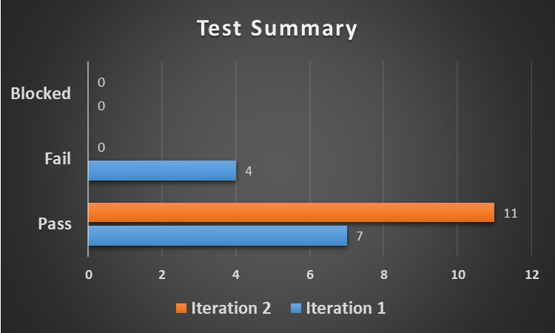

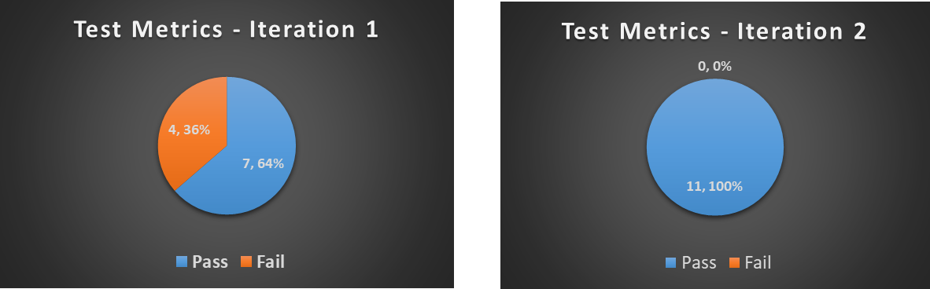

|  |  |  |  |  |
| --- | --- | --- | --- | --- |
| **Test Execution Status** | | | | |
| **Iteration Details** | **No of Testcases** | **Executed** | **Blocked** | **Not Executed** |
| **Iteration 1** | 11 | 11 | 0 | 0 |
| **Iteration 2** | 11 | 11 | 0 | 0 |

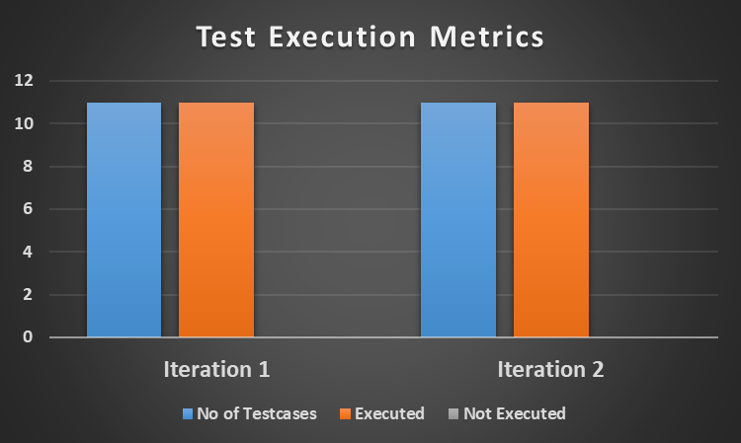

***Test Coverage***

*The table summarizes the test coverage criterion used in determining the testing of systems, subsystems, logic, functions, or features.*

| ***Test Coverage***  ***(e.g., Logic, Function, Feature)2*** | ***Prioritization***  ***(e.g., High, Medium, Low)*** | ***No. Of Possible Test Cases*** | ***Actual No. Of Test Cases*** | ***% Test Coverage*** |
| --- | --- | --- | --- | --- |
| *User Login* | ***Medium*** | ***10*** | ***9*** | ***90%*** |
| *New user registration* | ***High*** | ***20*** | ***18*** | ***90%*** |
| *Role management* | ***High*** | ***30*** | ***30*** | ***100%*** |
| *Customer management* | ***Medium*** | ***25*** | ***25*** | ***100%*** |
| *Reports management* | ***Low*** | ***15*** | ***10*** | ***66%*** |

***Defect Report***

*This table provides a high-level overview of the application quality in terms of defect quantities, types, severity level, and final state. The defect quantities should be compared to the exit criteria as stated in the Master Test Plan or level test plan to verify whether the number of defects by type and severity level are appropriate.*

|  |  |  |  |  |
| --- | --- | --- | --- | --- |
| ***Severity Level Of Defect*** | ***Total No. Of Defects Found In The Test Level*** | ***Total No. Of Defects Closed At The End Of The Test Level*** | ***Total No. Of Defects Open At The End Of The Test Level 3*** | ***Describe Impact To Application Of Postponed Function*** |
| *Critical* | *2* | *2* | *0* | *No Provision of Export function across the portal*  *No password encryption has been enabled* |
| *Major* | *1* | *1* | *0* | *Account lockout functionality – Not working as expected* |
| *Average* | *1* | *1* | *0* | *Session handling has not been carried out. No direct impact to functionality* |
| *Minor* | *0* | *0* | *0* |  |

*\*\*In case of any open defect – it will be postponed and fixed in a future planned release.*